**Prime Exercises**

1. Four numbers a, b, c, d are all prime numbers, and a + b = 33, b + c = 44, c + d = 66. What is a x b x c x d?
2. Seven consecutive prime numbers, from large to small, are a, b, c, d, e, f, g. The sum of these prime numbers is an even number. What is c?
3. All the even numbers are the sum of two prime numbers. For 168, what are the two two-digit prime numbers while one of the prime number unit digit is 1?
4. How many subsets of $\{2,3,4,5,6,7,8,9\}$contain at least one prime number?
5. Goldbach's conjecture states that every even integer greater than 2 can be written as the sum of two prime numbers (for example, $2016=13+2003$). So far, no one has been able to prove that the conjecture is true, and no one has found a counterexample to show that the conjecture is false. What would a counterexample consist of?

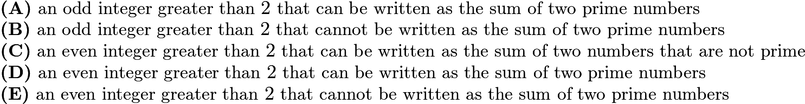

1. Using the digits 1, 2, 3, 4,5,6,7 and 9, form 4 two digit prime numbers, using each digit only once. What is the sum of 4 prime numbers?